Said Changes to be Done for MSME Payment Method M only

- Fetch Partner No. from EDIDC-RCVPRN

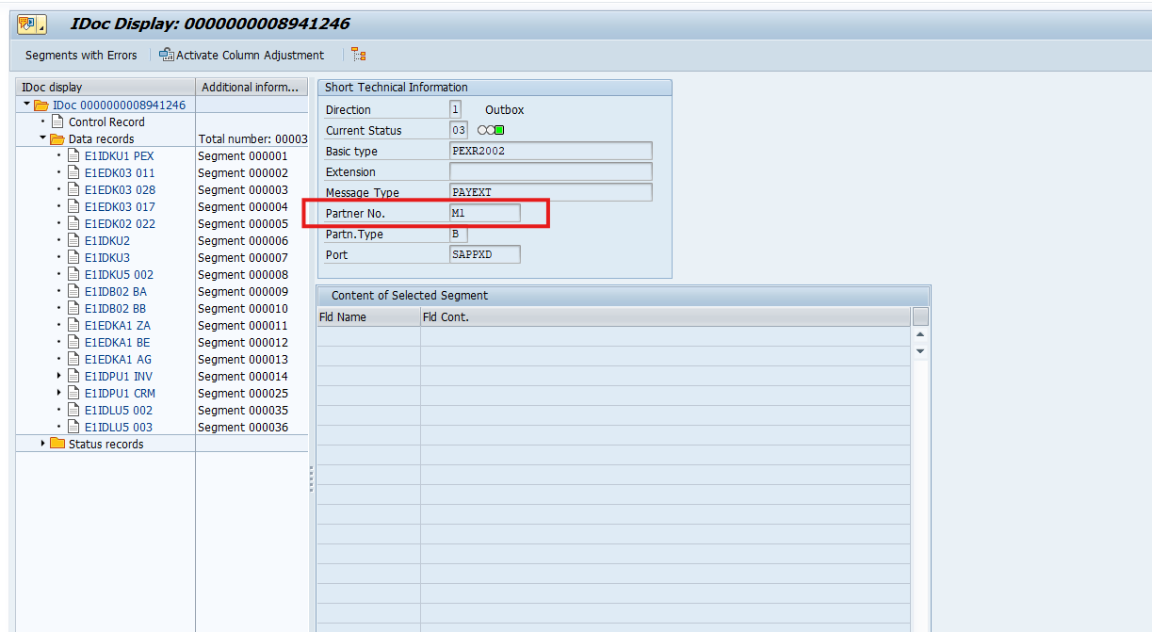

Convert Partner No. into Indicator . It is the domain Value of Table ZFI_TREDS_MSME_V - SELIDTYP
Partner No. | Indicator
M1 | M
RxIL | R
Invoicemart | I
DTX | D
C2FO | C

We are already fetching few information based on PYORD from table
ZFI_BCM_PAYORDR, Fetch LIFNR also

Pass LIFNR & Indicator in Table ZFI_TREDS_MSME_V

Match with LIFNR + SELIDTYP of Table ZFI_TREDS_MSME_V

Fetch SELLER_ID

Substitute Seller ID in the given field of IDoC

E1EDKA1 BE TELFX
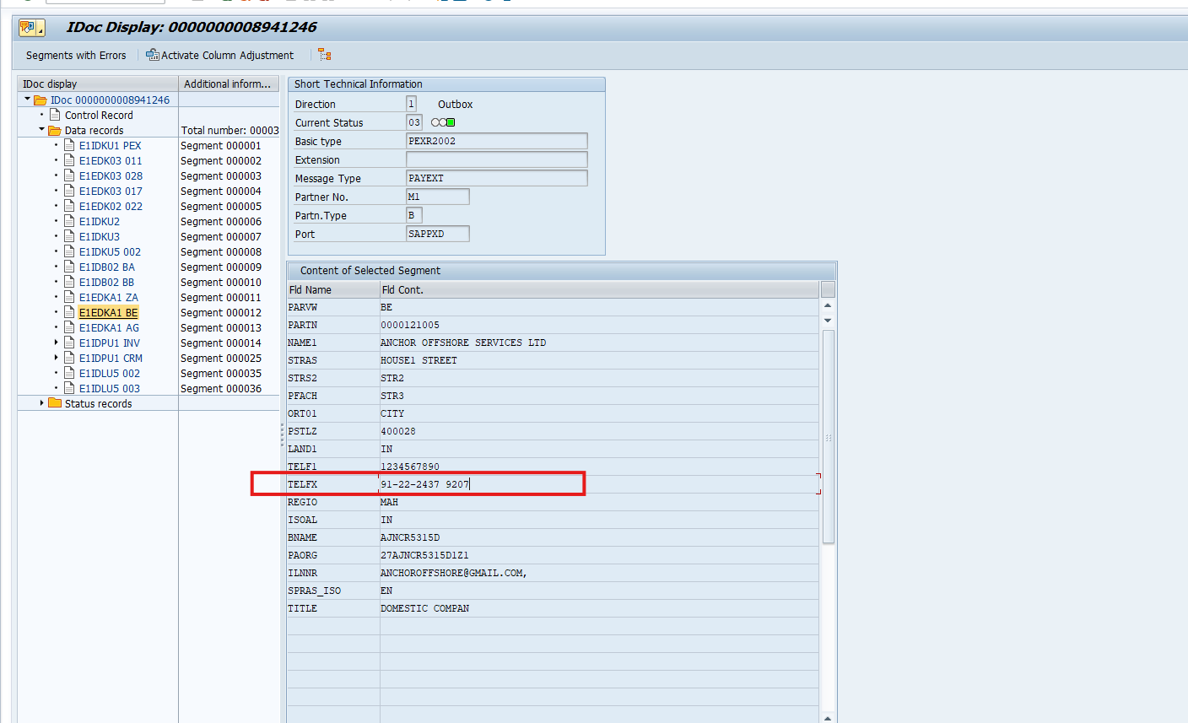

2. Fixed Value to be placed in

E1EDKA1 AG ORT01 PRODUCT
